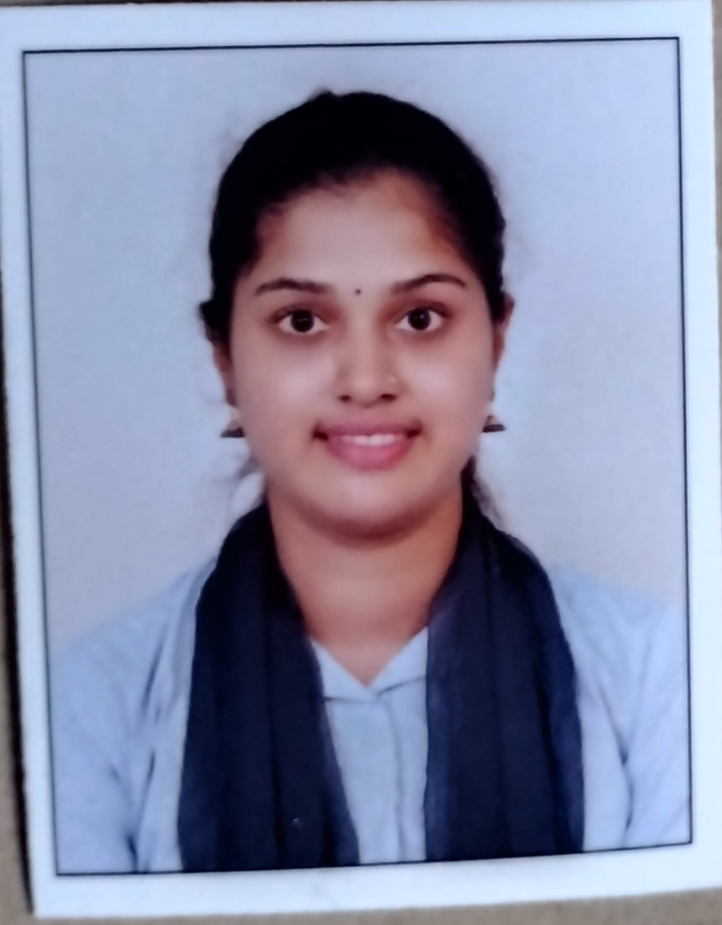
I’m Seeking opportunities to join a company that can help me in enhancing my skills , strengthening my knowledge, and realising my potential. I am willing to explore a wide variety of opportunities that can help me gain perspective.
Summary
S
Education
2023 – Master of Commerce
POORNAPRAJNA COLLEGE , POST GRADUATE STUDIES IN COMMERCE, UDUPI
(Affiliated to Mangalore University , Mangalore)
- Current CGPA 7.61
- Specialized in Taxation

2021- Bachelor of Commerce
POORNAPRAJNA COLLEGE, UDUPI
(Affiliated to Mangalore University, Mangalore)
- Graduated with 86.40%

2018 – Pre-University College
TRISHA PU COLLEGE, KALLAINPURA , SANTEKATTE , UDUPI
(Department of Pre-University Education, Bangalore)
- Graduated with 94%

2016- Secondary Level School Certificate (SSLC- 10th Std.)
SRI VISHWAKARMA HIGH SCHOOL, BELLAMPALLI, UDUPI
(Karnataka Secondary Education Examination Board , Bangalore)
- Graduated with 81.44%

Contact
- Finance
- Writing
- Reading

Skills
Field of Interest
- Communication
- Writing
- Leadership
- Creativity
- Time management
- Team Work
- Technical Skills

Phone
+91 7348981376
Email
shettysuchira645@gmail.com
Address
109 2 72A Classic Kausthubha
Vasukinagar, Ambagilu
Udupi, Karnataka - 576102

SUCHIRA

- CA .K. GANESH M KAMATH OFFICE, TENKUPETE,UDUPI
October 2022 – November 2022
Role : Trained in the area of “Vouching and Basic Taxation” for 10 days

- TUTEDUDE E-LEARNING PLATFORM(Virtual)
January 2023 – February 2023
Role : Business development and marketing intern

- PHN TECHNOLOGY (Virtual)
April 2023 – June 2023
Role : Human Resource Intern

- INTERNBUG (Virtual)
June 2023 – June 2023
Role : Campus Ambassador intern for 15 days
Languages

- English
- Kannada
- Tulu
I Internship
Strength
PPlace : Udupi
Date : 22/08/2023

Suchira
Place : Udupi
Murali Paniyoor
Lecturer
Poornaprajna College , Post Graduate studies in Commerce, Udupi
+91 9986845274
Reference
I here by declare that to my knowledge the information provided
Above is true and fair .
Declaration
- Dedicated
- Honesty
- Flexible
- Discipline
- Creative
Projects
- STUDY ON CUSTOMER SATISFACTION OF RELIANCE SMART IN UDUPI CITY
Period : 3 Months Team Size : 8
During M.Com this minor research done within our team.

- OUTREACH PROGRAMME AT VOLAKADU GOVERNMENT HIGH SCHOOL , UDUPI
Period : 1 day Team Size : 8
During M.Com teaching to the school students about digital payment within our team.
- Bonda Factory, Adyar , Mangalore
- KMF , Mangalore
Quote writing in Kannada,
Tulu and English
- Diploma in Computer Application
- Know your Economy Test
- Digital 101 Journey
Certifications
Hobbies
Industrial Exposure

